**Learners’ Perspective: 21st Century Essential Fluencies**

**ABSTRACT**

The environment we live in is constantly changing and the ability to stay ahead of time is part of one’s survival. Educators of today face the challenging need to adapt their pedagogical approaches to meet the needs of their 21st century learners. It is imperative to know the value placed by learners towards the 21st century skills and knowledge to better understand them and their learning behaviour. Through this, educators are able to tailor educational needs to meet future needs of both learner and society. The quantitative study was conducted with 197 pre-university students at a private university in Malaysia. Two instruments were used to design the questionnaire for the study; “What We Educators Get Wrong about 21st- Century Learning: Results of a Survey by Mishra and Mehta (2016) and “How Do Students Value the Importance of Twenty-first Century Skills?” by Ahonen and Kinnunen (2015). The results of the study shed insights on emerging trends as society and technology are evolving and this would be vital for educators to stay relevant in educating the future workforce

**KEYWORDS: 21st century skills, learners, educators, technology, knowledge**

**Introduction**

Organisations and educational institutions have placed a lot of emphasis on 21st century skills. With globalization, internalization and technological advancement, we see a great need to equip the future generation with the right knowledge and tools for the 21st century demands. More and more industries are gearing up to prepare for the 21st century requisites, which also affects tertiary education providers to reform their current curriculum. The responsibility seems to fall on educators to prepare students to be able to work and survive in this environment. Not only this, educators are also to cater for the work force needs of a country to develop, strengthen and support its economy, infrastructure and society.

Technological advancement has changed how 21st century learners develop themselves and their interest from those of the 20th century. In fact, both educators and learners have many doors opened in how they seek, obtain and apply knowledge gained. With infinite information available anytime anywhere to learners, educators need to keep abreast with the latest information and technology tools in order to stay relevant for their learners. Skills such as digital literacy, communication, collaboration, cultural awareness, critical thinking and creativity play an important part in the information based economy; making pure conventional content knowledge insufficient for 21st century learners.

To produce an all-rounded-learner, all perspectives is best to be taken into consideration, including learners’ perspective on the subject matter. Knowing learners’ perspective builds on educators’ knowledge regarding their learners thus enabling them to stay relevant, build more effective learning interventions and better tailor their teaching resources to the learners need for their future. Gentilucci (2004, p.133) states, “Students are powerful determiners of the learning that occurs in their classrooms. Understanding why they learn well or poorly is predicated upon clearly understanding their perspectives on learning”. Furthermore, learners have a way of influencing future society and matters that trend. Thus, understanding their perspective on 21st century skills contributes to how they view their future needs, leading to information on learners’ learning-related behaviour.

There are many research that looks into the area of teaching, educators and 21st century skills but there are not many research conducted on the learners’ perspective towards 21st century skills. Ahonen and Kinnunen (2015, p.397) also echoed this sentiment by indicating that there are not a lot of studies obtainable on learners themselves valuing or ranking the 21st century skills or any other list of skills conferred to them. Thus, this gives rise to the need of the current study.

Taking these into consideration, the aim of the study was to find out on learners’ opinions regarding the significance of the skills they would need for their future as well as how they acknowledge and value 21st century skills. This study also accounts the skills that students have attained on their own during their free time noting its importance for their future need.

Following the above, the study looks into the following research questions:

1. What types of skills do learners foresee they will need in the year 2025?
2. How do learners rank and value the importance of 21st century skills?
3. What skills do the learners indicate as being the most significant they have attained so far on their own?

**Literature review**

As we transition from the 20th century to the 21st century, many expected changes would be a part of this new era. Among these aspects are the current revolution in education, especially with the skills we think are important to equip our learners with and to be able to adapt to the needs of the 21st century work environment. The current generation that is most affected by the 21st century skills is the Generation Z, which are individuals born after 1996. This group has the longest time to serve in the workforce; thus making it imperative that educational institutions and companies alike can play to their strengths. This generation is known to be tech savvy and have their own expectations, as many of them are comfortable working in teams rather than being alone in a working environment (Nichols & Wright, 2018).

There are many frameworks on 21st century skills such as Partnership for 21st Century Skills, Assessment and Teaching of 21st Century Skills (ATC21S) and Tony Wagner’s Global Achievement Gap Seven Survival Skills, to name a few. However, as pointed out by Voogt and Roblin (2012), many of these frameworks share similarities especially in skills like Problem Solving, Critical Thinking, Creativity, Innovation, Communication and Collaboration (van Laar, van Deursen, van Dijk, de Haan, 2017, p. 578).

Binkley, et.al (2012) indicated that ATC21S has classified required 21st century skills into four categories and ten skills (van Laar, van Deursen, van Dijk, de Haan, 2017). They are *Ways of Thinking* (Creativity and Innovation, Critical Thinking, Problem Solving and Decision Making, Learning to Learn and Metacognition), *Ways of Working* (Communication, Collaboration- teamwork), *Tools for Working* (Information Literacy, ICT Literacy), *Living in the World* (Citizenship -local and global, Life and Career, Personal and Social Responsibility).

Similarities are seen in Kereluik et. al.’s (2013) *The 3 x 3 Model of 21st- Century Learning framework* which consist of three general type of knowledge and within each knowledge, further three subcategories of knowledge were categorized (illustrated below). However, Mishra and Mehta (2017, p. 15) emphasized that the Kereluik et. al. (2013) framework is “a more balanced approach that affords students the opportunity to learn at the intersection of the three knowledge domains, where each set of knowledge has its own unique role to play in the 21st century, none of which should be more or less significant than the other”. On another note, the question does arise as to whether learners or students perspective towards these 21st century skills and knowledge were taken into consideration when frameworks were formed.

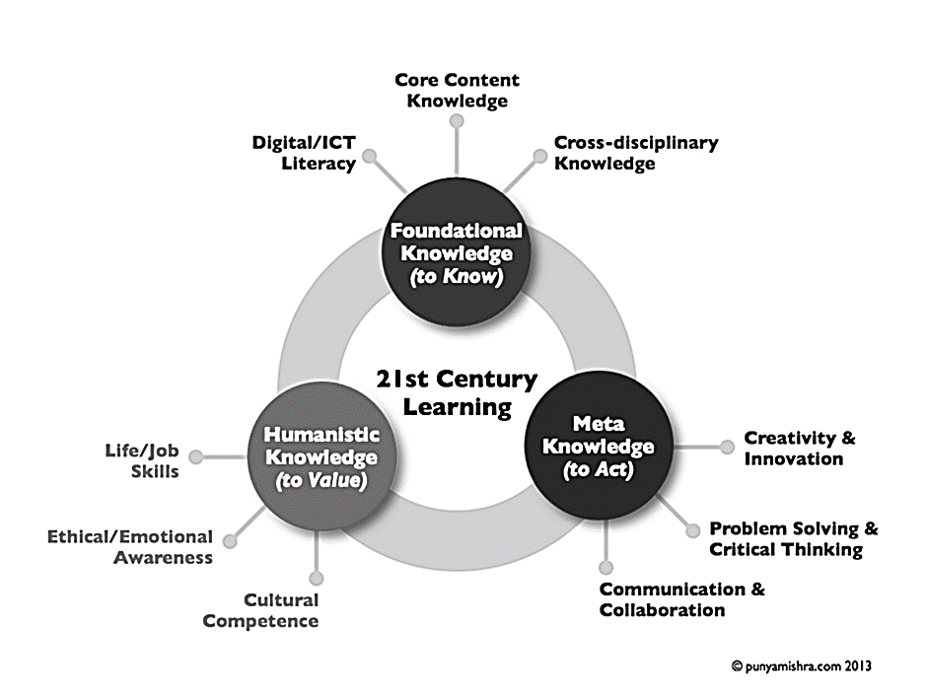

*Figure 1.* The 3 x 3 model of 21st century learning, following Kereluik et.al. (2013) framework (Mishra and Mehta, 2017, p. 8)

Learners need to be well equipped with 21st century skills to ensure that their productivity in the workforce will not be hampered. For them to be well prepared for the unforeseen challenges in the future working environment, they need to spend considerable time developing their skills set. Based on a study of using project-based learning to teach 21st century skills that was conducted by Bell (2010), among the skills that are seen to be relevant by learners are their ability to collaborate, negotiate, plan, and organise. Being in the team is essential, and also knowing what students’ view as being important for their future is vital too.

Students have their own opinions on the skills that they would require to be successful in their employment later on. Kalelioglu & Gülbahar (2014) looked at 5th grade students’ perception of being taught programming in primary school as part of being equipped for the 21st century. The study concluded that students liked programming and wanted to improve their skills. Thus, this suggest that most students already know what they want and what is essential to be successful in their lives. It is then our responsibility to also ensure that their voices are heard and taken into consideration when planning the syllabus and frameworks.

Voogt & Roblin (2012) pointed out that in order to prepare the next generation to be work ready, the current knowledge and skill-set has to undergo a paradigm shift to reflect the changes ongoing in the society. There are a plethora of studies done in many fields that look at the impact of 21st century skills for the future workforce, but mostly focus on the educational institutes and educators rather than the students. The findings echo the studies done by Ahonen & Kinnunen (2014) and Betts, Kapushion & Carey (2016). These studies not only looked at the 21st century skills from the learner’s perspective, but also to ruminate and execute a plan based on the 21st century skills which were considered important for these students.

Richardson (1996) and Borko and Putnam (1995) indicated that teachers’ belief and thoughts would influence the knowledge and skills taught to students and their own knowledge and skills development. Therefore, by knowing the learners’ perspective of 21st century skills and knowledge, it would enable them to have a better understanding of their students and learn-related behaviour, attitude and interest. With this knowledge, educators are able to stay relevant, build more effective learning interventions and better tailor their teaching resources. In fact, this would enable educators to better position a skill that students seem to undervalue.

Taking everything into account, there is a need to know and understand what learners believe are significant 21st century skills and knowledge or essential fluencies. This would not only enhance educators’ pedagogical content and approaches, but also give a better and all-rounded reflection of 21st century framework.

**Method**

In order to achieve the objective of this study, a survey-based questionnaire was used as research method. An online questionnaire with a combination of adapted questions from Ahonen and Kinnunen (2015) research paper, Mishra and Mehta (2017) research paper and Kereluik, Mishra, Fahnoe and Terry (2013) The *3 x 3 Model of 21st- Century Learning* framework were used to obtain information from the participants. Online questionnaire allowed quick online feedback or response, allowing the researchers to collect and analyse surveys efficiently (Wright, 2005).

*Participants*

The target students’ population in this study was from a private Malaysian university in Selangor, Malaysia. Using the convenience sampling method, students from the pre-university programmes were used due to accessibility and proximity to the researchers. 197 Foundation students from various programmes participated and completed the online survey.

The age range of these students were between 16 years old to 19 years old. Due to the age range, these participants are part of the Generation Z, also known as the digital natives. According to NST (10 Jan 2018), Malaysian Gen Z students consider themselves as “ambitious, curious and creative” however, they are also anxious about their future livelihood. The article goes on to state that a number of Gen Z within Malaysia feel what they learn outside of the classroom is more important to their future jobs than what they obtain inside the classroom. Thus, using this sample group would shed light to the research questions set for this study.

*The Instrument*

The survey started with asking the students background information; however, information asked were limited to age, gender and programme they were undertaking. The following section consisted of two open-ended questions. The first question was to list three skills or knowledge they would need in the year 2025. This question was asked to enable the researchers to get a sense of what students perceived as important challenges, skills and knowledge of the 21st century and what they would need to face and survive in this century.

In the next section of the survey, using Kereluik et al.’s (2013) The 3 x 3 Model of 21st- Century Learning framework, students were asked to rate the importance (1 being the most important and 9 being the least important) they believed as significant knowledge for the 21st century. The nine types of knowledge were core content knowledge, cross-disciplinary knowledge, and digital/ICT literacy (that constitute foundational knowledge); problem solving and critical thinking, communication and collaboration, and creativity and innovation (that constitute meta knowledge); and life/job skills, cultural competence, and ethical/emotional awareness (that constitute humanistic knowledge) (Mishra & Mehta, 2017 p. 9). Through this section, it enabled the researchers to gain information on how students valued each of these knowledge.

The final section of the survey comprised of an open-ended question. The question required the students to state what were the most important skills or knowledge they had learned on their own during their free time. This gives the researchers information on the self-initiative students take to build themselves up with the kind of skills or knowledge they find significant for their future.

*Collecting Responses*

The data was collected via an online questionnaire (Google Form), which was posted on the students’ English module site on Moodle. A brief introduction was provided of the study so the students were aware the purposes of it. Administering the survey online increased accessibility as it gave respondents various ways to access the survey at anytime and anywhere such as through their mobile phones, laptops, tablets, etc. Another major benefit of using this method (Google Form) was it enabled quick results, as data received was automatically tabulated.

The survey link was made available to the students for two weeks. Once the survey closed, data obtained was statistically analysed. The demographic section produced descriptive statistics while the open-ended questions in the survey were coded to identify emerging trends and thematic groups. From this, the information gathered was triangulated against available data and theory. The section on rating of the 21st century knowledge were compared with each other for significance and across categories of knowledge to underscore which knowledge students valued the most.

**Results**

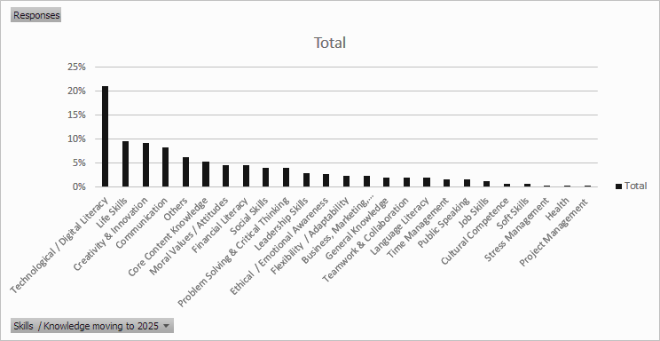The following are the responses received from the survey completed by the students.

*Figure 2.* Students response on skill/knowledge needed by them moving to the year 2025

Figure 2 illustrates the skills/knowledge that students have indicated as needed by them as they move to the year 2025 for employment purposes. Digital literacy at 21.12% is the most important skill, followed up by life skills at 9.57% and creativity and innovation at 9.24%. Notably, stress management, health and job skills at 0.33% respectively were the lowest skills/knowledge required in their perspective.

*Table 1.* Students response on skill/knowledge based on importance

|  |  |  |
| --- | --- | --- |
| **Knowledge** | **Mean** | **Standard Deviation** |
| Problem Solving / Critical Thinking | 1.96 | 1.595 |
| Communication and Collaboration | 2.14 | 2.032 |
| Life/ Job Skills/ Leadership | 2.29 | 1.909 |
| Ethical / Emotional Awareness | 2.35 | 1.874 |
| Digital / ICT Literacy | 2.49 | 1.947 |
| Creativity / Innovation | 2.53 | 2.113 |
| Cross-Disciplinary Knowledge | 2.80 | 2.159 |
| Core Content Knowledge | 2.86 | 2.268 |
| Cultural Competence | 3.63 | 2.484 |

Table 1 shows students’ rating results based on a scale of 1 (most important) to 9 (least important) of the most and the least important skills to have in the 21st century. Students were asked to rate based on the nine kinds of domains based on Kereluik (2013) *The 3 x 3 Model of 21st – Century Learning Framework.* The results show that students indicated that problem solving/ critical thinking as the most important (M=1.96, SD=1.595), followed by communication and collaboration (M=2.14, SD=2.032) and life/job skills/leadership (M=2.29, SD=1.909). The least important skills obtained through the responses was cultural competence (M=3.63, SD=2.484).

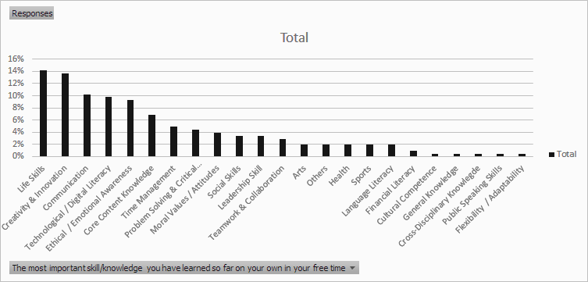

*Figure 3.* Important skill/knowledge students deemed important they have attained so far in their own time.

Figure 3 presents the responses that required students to identify skills that they have learnt outside the typical academic setting. These are skills/knowledge they deemed being the most important that they have attained on their own thus far. From the responses, we can see that they have spent time learning skills/knowledge in the areas of life skills (14.15%), creativity and innovation (13.66%) and communication (10.24%). The lowest skills ranking included cross-disciplinary knowledge (0.49%), public speaking skills (0.49%) and flexibility or adaptability at 0.49%.

**Discussion**

Based on the overall results, most students are aware of the potential challenges that they will face when they start working in the 21st century work environment.

*Research Question 1: What types of skills do learners foresee they will need in the year 2025?*

Most respondents chose digital literacy (21.12%) as the most vital skill for their transition to the 21st century work setting as seen from the data in Figure 2. This chosen skill was significantly higher than the second skill - life skill that was 9.57%. Here the students are wary of the skill that they need to master before commencing their work at a potential company. It is also interesting to note that they have a need for work life balance as the second most important skill indicated is life skills. Youthsight (2018) indicated that Gen Z loves learning, self-development and crave basic life skills. This gives rise to importance placed on life skills in the students’ responses, a need to have skills in managing and living a better quality of life. Creativity and innovation (9.24%), the third most important skill indicated through the responses, shows that students are aware that subject content alone will not sufficiently support the impending challenges, thus they need to be creative and find different means of problem solving to ensure their success at work.

This finding corroborates with a study by Edelman Intelligence of 250 Gen Z students between the ages of 11 and 17, and 100 teachers in the country that indicated that 97% of students and 100% of teachers see creativity as essential to students’ future success (NST, 10 Jan 2018). Apart from this, Roman (2018) also indicated Gen Z as tech native “crave innovation and entrepreneurship—55%, globally, want to start their own companies”. This to a certain extend supports the students’ responses for the expertise needed in the area of innovation in the year 2025. It is also interesting to note that the three commonly mentioned skills are included in existing 21st Century Frameworks – students do find them relevant.

*Research Question 2: How do learners rank and value the importance of 21st century skills?*

From Table 1, students rating results were based on a scale of 1 (most important) to 9 (the least important) of the most and the least important skills to have in the 21st century. From the responses of 197 students, problem solving/ critical thinking was the most important (M=1.96, SD=1.595) 21st century skill to possess. This skill is also seen to be essential for most potential employers to seek in their future employees.

Communication and collaboration (M=2.14, SD=2.032) is the second important 21st century skill valued by the students. This is also similar to the findings of Ahonen and Kinnunen (2015), which also found many students actually stating that collaboration is an important skill for them. The third highest valued 21st century skill was life, job skills and leadership skills (M=2.29, SD=1.909). Students are also associating skills of leadership, ability to perform a job related task and life skills as essential aspects to do well in their professional lives.

On the other end, the least important skill was cultural competence (M=3.63, SD=2.484). A possible argument for this could be due to globalization and being in a multiracial community, most students already have experience relating and working with fellow students from other races and nationalities, thus the transition is not that difficult since they are already used to working with peers from culturally diverse backgrounds from their tertiary educational settings. Moreover, many students are also pursuing studies abroad, enabling them to also adapt to the different cultures they see at the country they reside for the duration of their study. However, it is interesting to note that in Ahonen and Kinnunen’s study (2015), their respondents of the study also indicated cultural competence the least valued and ranked 21st century skills.

In Kereluik et al. (2013), we read that all nine key domains including cultural competence should play an equal significance in the knowledge needed for the 21st century. Thus, knowledge of the importance and value placed by students on the 21st century skills would enable educators to understand learners’ learning-related behaviour. This in turn would enable educators to tailor their manner of teaching and materials towards the learners’ need, behaviour and interest.

*Research Question 3: What skills do the learners indicate as being the most significant they have attained so far on their own?*

The data in Figure 3 highlights the skills that students in this study mastered on their own time. The most important skill that a majority of students mastered at 14.15% is life skills followed by skills on creativity and innovation at 13.66%. The third most important skill mastered is communication at 10.24%. It is imperative to note that these skills mentioned are a part of the essential skills identified by students earlier as having a huge importance in their future. The data in the current study indicates that students also have other avenues of getting the required skills outside the typical tertiary setting and can associate their experience outside the classroom as part of their development of skills for their future career.

It is also interesting to note that life skills, the skill that the majority of students mastered in their free time, is also indicated as the second most important skill that students feel is required in 2025 (Figure 2). It is also valued as the third most important skill of the 21st century skills (Table 1) by the students in this study. There is certain amount of consistency noted through these data and as stated by Youthsight (2018) the Gen Z do value life skills. A similar pattern can be seen with creativity and innovation, the second highest skill that students mastered during their free time. This skill was considered the third most important skill indicated by students as needed in 2025 (Figure 2) and the six most valued skills of the 21st century skills (Table 1). The importance placed in these skills is also supported by NST (10 Jan 2018) and Roman (2018) stating how Gen Z foresee creativity and innovation as skills leading to their future success.

In contrast, with 0.49% respectively, students also picked up skills like cross-disciplinary education, public speaking skills and flexibility or adaptability in their own free time. However, these skills are not as popular as the rest. The possible reason for this could be because courses like public speaking skills and cross-disciplinary skills are more easily obtained via a formal educational setting like in classrooms rather than in isolation during time spent outside the class. In addition, it is also clear that many students already feel that these skills do not need to be ‘picked up’ during time outside the formal education setting, as they would have already acquired it in classes that they attend.

**Limitation of the study**

As much as the study achieved the researchers intend for this study, there were several limitations to it looking from the ability to generalize conclusion to a larger population. The first limitation is the participants of the study were all in their first semester and enrolled for a pre-university course; therefore, their perceptions may not be the same as students who are currently at the undergraduate or postgraduate level of their study. Apart from this, convenience sampling was used thus data cannot be taken as a representative sample of the student population in Malaysia. Furthermore, the statistical analyses is only at a descriptive and exploratory level.

**Conclusion**

Based on the current study, we do see students value and acknowledge the importance of 21st century skills and knowledge. We see this through the importance they place on problem solving/ critical thinking, communication and collaboration, life skills/job skills/leadership, technology / digital literacy, creativity and innovation, etc. Furthermore, data does show that students on their end do build and develop skills needed for their future in their free time.

Recognising learners’ views and value of these skills (even those undervalued and underappreciated) would help pedagogical practices and evaluation. This is turn would enable educators to develop and convey their content and materials accordingly to ensure better appreciation and motivation in learning these essential 21st fluencies amongst students. It would also ensure the necessary support be provided for the students in acquiring and developing these skills set and knowledge for their future needs, may it be in their work life or personal life or social life.

Certain recommendations for future studies may be made from this current study. A larger sample size of data collected in this area would enable sound statistical methods to be applied in order to obtain better insight into students’ appreciation of 21st century essential fluencies. It would also enable better generalization of findings obtained. Apart from this, obtaining input from students across different levels from pre-university right up to postgraduate would enable to see if there are changes in students’ perception of the most important skill and least important skill as they proceed in their chosen tertiary study.

It would also be interesting to see whether students’ response based on gender would have a different set of skills that would be valued as important. It would be interesting to see if male and female rate skills like digital literacy and communication the same since they may have other preferences that they would think is more important to succeed in their future work environment.

**References**

Ahonen, A. K., & Kinnunen, P. (2015). How do students value the importance of twenty-first century skills?. *Scandinavian Journal of Educational Research*, *59*(4), 395-412.

Bell, S. (2010). Project-based learning for the 21st century: Skills for the future. *The Clearing House*, *83*(2), 39-43.

Betts, G., Kapushion, B., & Carey, R. J. (2016). The autonomous learner model. In *Giftedness and Talent in the 21st Century* (pp. 201-220). SensePublishers, Rotterdam.

Borko, H., & Putnam, R. T. (1995). Expanding a teacher’s knowledge base: A cognitive psychological perspective on professional development. In T. Guskey & M. Huberman (Eds.), *Professional development in education: New paradigms and practices* (pp. 35–65). New York: Teachers College Press.

Gentilucci, J. (2004). Improving School Learning: The Student Perspective. *The Educational Forum*, 68(2), pp.133-143.

Kalelioğlu, F., & Gülbahar, Y. (2014). The Effects of Teaching Programming via Scratch on Problem Solving Skills: A Discussion from Learners' Perspective. *Informatics in Education*, *13*(1).

Kereluik, K., Mishra, P., Fahnoe, C., & Terry, L. (2013). What knowledge is of most worth: Teacher knowledge for 21st century learning. *Journal of Digital Learning in Teacher Education, 29*(4), 127-140.

Richardson, V. (1996). The role of attitudes and beliefs in learning to teach. In J. Sikula (Ed.), *The handbook of research in teacher education* (2nd ed., pp. 102–119). New York: Macmillan.

Roman, S (2018). “Millennials are tech savvy. Gen Z’s are tech native.” Podcast. Top Employers Institute. Retrieved July 22, 2018, from https://www.top-employers.com/en/insights/millennials-are-tech-savvy-gen-zs-are-tech-native-shaara-roman/

Mishra, P., & Mehta, R. (2017). What We Educators Get Wrong About 21st-Century Learning: Results of a Survey. *Journal of Digital Learning in Teacher Education*, 33(1), 6-19.

Nichols, T., & Wright, M. (2018). *Generational Differences: Understanding And Exploring Generation Z*. 2017-2018 Officers President President-Elect, 177.

New Straits Times (NST) (2018, January 10). Gen Z sees creativity as key to success. Retrieved from https://www.nst.com.my/education/2018/01/323612/gen-z-sees-creativity-key-success

van Laar, E., van Deursen, A. J. A. M., van Dijk, J. A. G. M., & de Haan, J. (2017). The relation between 21st-century skills and digital skills: A systematic literature review. *Computers in human behavior*, *72*, 577-588. DOI: 10.1016/j.chb.2017.03.010

Voogt, J., & Roblin, N. P. (2012). A comparative analysis of international frameworks for 21st century competences: Implications for national curriculum policies. *Journal of curriculum studies*, 44(3), 299-321.

Wright, K. B. (2005). Researching Internet-Based Populations: Advantages and Disadvantages of Online Survey Research, Online Questionnaire Authoring Software Packages, and Web Survey Services. *Journal of Computer-Mediated Communication*, Vol 10, No. 3, article 11.

YouthSight (2018) *Millennials want to learn a new language. Gen Z just want to know how to communicate.* [PDF file] Retrieved from http://www.youthsight.com/wp-content/uploads/2018/06/YS-Spotlight-01221117-skills-desired-01201017.pdf